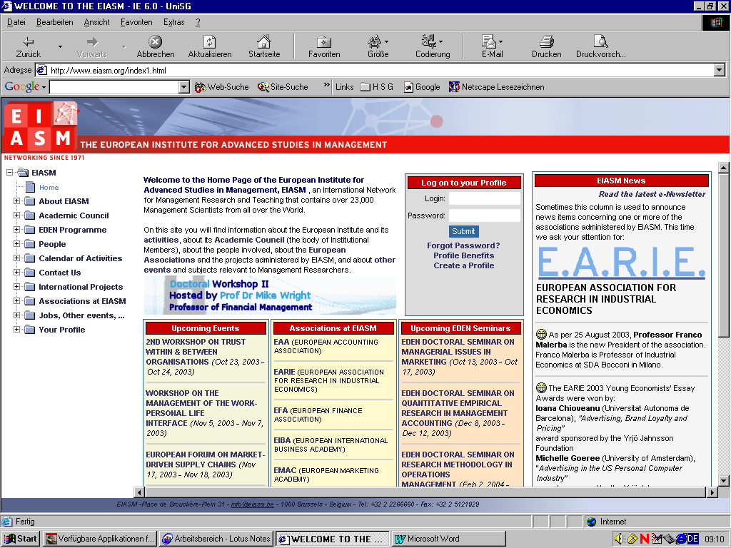
PLACE DE BROUCKÈRE-PLEIN - 31 - 1000 BRUSSELS - BELGIUM - Tel: 32 2 2266660 - Fax: 32 2 5121929

WORKSHOP
ON
STRATEGIC HUMAN RESOURCE MANAGEMENT
PROGRAMME
April 6-7, 2009
CHAIRPERSONS :
Professor Martin HILB - University of St. Gallen, Switzerland
Professor Dan ONDRACK - University of Toronto, Canada
Professor Michael SEGALLA - HEC School of Management, France

Monday, April 6, 2009
08:30 – 09:00 | Registration
09:00 – 09:30 | Introduction
TRACK A : STRATEGIC HRM
Chairperson : Martin Hilb
09:30 – 10:00 | THE CENTRAL ROLE OF THE HUMAN RESOURCE FUNCTION IN EFFECTIVE CORPORATE GOVERNANCE  VANCE CHARLES, (LOYOLA MARYMOUNT UNIVERSITY - U.S.A.) -
10:00 – 10:30 | CREATING A CLIMATE FOR INTER-ORGANIZATIONAL NETWORKING THROUGH PEOPLE MANAGEMENT  JOLINK MARK, (RADBOUD UNIVERSITY NIJMEGEN - NETHERLANDS) - BEN DANKBAAR
10:30 - 11:00 | NOT BLACK AND WHITE: THE FUTURE OF STRATEGIC HRM IS GREEN  VELLELLA ROBERT, (UNIVERSITY OF MINNESOTA - U.S.A.) -
11:00 – 11:15 | Coffee Break
11:15 – 11:45 | TOP MANAGEMENT TEAM DIVERSITY AND INNOVATION - PROGRESS OF A RESEARCH PROJECT  STOLARSKI VERA, ( - GERMANY) - MEIKE TILEBEIN
11:45 – 12:15 | GENDER AND DIVERSITY: IS A NEW MODEL OF HRM NEEDED? A REVIEW OF HRM PRACTICES IN THE ALSACE REGION OF FRANCE  LOVANIRINA RAMBOARISON-LALAO, (STRASBOURG III UNIVERSITY / IAE MANAGEMENT SCHOOL - FRANCE) - GILLES LAMBERT
12:15 – 12:45 | FEMINISATION AND DEPARTMENTAL STATUS: THE CASE OF HR DEPARTMENTS  REICHEL ASTRID, (VIENNA UNIVERSITY OF ECONOMICS AND BUSINESS ADMINISTRATION - AUSTRIA) - JULIA BRANDL - WOLFGANG MAYRHOFER
12:45 - 14:15 | Lunch
TRACK B : Motivation and Competence Management
Chairperson : Daniel Ondrack
14:15 – 14:45 | TOWARDS A CONCEPTUAL MODEL OF COMPETENCY DEVELOPMENT IN ORGANIZATIONS: A QUALITATIVE STUDY OF ORGANIZATIONAL POLICIES AND PRACTICES  DE HAUW SARA, (VLERICK LEUVEN GHENT MANAGEMENT SCHOOL - BELGIUM) - ANS DE VOS
14:45 – 15:15 | EXPLORING THE LANDSCAPE OF COMPETENCY MANAGEMENT AND OUTCOMES: A STATE OF THE ART OF THE RHETORICS COMPARED TO AVAILABLE EVIDENCE  AUDENAERT MIEKE, (HOGESCHOOL GENT - BELGIUM) - ALEX VANDERSTRAETEN, DIRK BUYENS
15:15 – 15:45 | THE STRATEGIC ROLE OF LIFELONG TRAINING IN INTERCULTURAL COMPETENCY DEVELOPMENT: THE YOUNG MANAGERS PROGRAM  (Y.M.P.) OF ARCELOR UNIVERSITY CASE  DRUMMOND VIRGINIA, (PARIS-DAUPHINE UNIVERSITY - PARIS IX - FRANCE) -
15:45 – 16:05 | Coffee/Tea Break
16:05 – 16:35 | INTENTION TO QUIT IN SOCIAL ENTERPRISES: THE ROLE OF JUSTICE, LMX, JOB SATISFACTION AND ORGANIZATIONAL COMMITMENT  OHANA MARC, (GROUPE ESC TROYES - FRANCE) - MARYLINE MEYER
16:35 – 17:05 | EFFECTS OF LEADERSHIP BEHAVIOUR ON JOB WITHDRAWAL INTENTIONS AMONG PUBLIC HOSPITAL NURSES  KOPONEN SIRPA, (JYVASKYLA UNIVERSITY - FINLAND) -
17:05-17:35 | THE RELATIONSHIP BETWEEN HRM AND CORPORATE ENTREPRENEURSHIP IN PORTUGUESE FIRMS  PROENÇA TERESA, (PORTO UNIVERSITY - PORTUGAL) - CATARINA DELGADO, MARINA PALMINHA
17:35 – 18:05 | THE INFLUENCE OF NEEDS, PERSONALITY CHARACTERISTICS, AND WORK MOTIVATION ON HUMAN RESOURCE MANAGEMENT STRATEGIES - A COMPARISON BETWEEN TRADITIONAL AND NON-TRADITIONAL LABOURERS  LEMMERGAARD JEANETTE, (SOUTHERN DENMARK UNIVERSITY - DENMARK) - VLAD VAIMAN - ANA AZEVEDO
19:30 | Informal Dinner

Tuesday, April 7, 2009

TRACK C : Performance Management
Chairperson : Michael Segalla
09:00 – 09:30 | THE (NON)SPREAD OF PERFORMANCE MANAGEMENT IN GOVERNMENT AGENCIES: IMPORTANCE OF THE STRENGHT OF THE SYSTEM  DECRAMER ADELIEN, (GHENT UNIVERSITY - BELGIUM) - ALEX VANDERSTRAETEN
09:30 – 10:00 | EMPLOYEE PERCEPTIONS OF HRM, AND THEIR IMPACT ON EMPLOYEE OUTCOMES  GILBERT CAROLINE, (KUL - LEUVEN CATHOLIC UNIVERSITY - BELGIUM) - SOPHIE DE WINNE - LUC SELS
10:00 – 10:30 | THE STRUCTURAL MODEL OF THE IMPACT OF ORGANIZATIONAL JUSTICE PRACTICES AND STRATEGIC HUMAN RESOURCE MANAGEMENT (SHRM) ON MUTUAL RELATIONS AND WORK PERFORMANCE OF DIFFERENT OCCUPATIONAL GROUPS.  UR REHMAN ATIQ, (ESC - LILLE BUSINESS SCHOOL - FRANCE) - PROF. CRISTOPHE BREDILLET
10:30 - 10:45 | Coffee Break
11:45 – 11:15 | HRM REFORM IN THE PUBLIC SECTOR ACROSS COUNTRIES: FROM PERFORMANCE MEASUREMENT TO PERFORMANCE STEERING ?  WAXIN MARIE, (AMERICAN UNIVERSITY OF SHARJAH - UNITED ARAB EMIRATES) - ROBERT BATEMAN
11:15 – 11:45 | CREATIVE HOME CITIES AS PART OF THE HUMAN RESOURCE STRATEGY  LEMMERGAARD JEANETTE, (SOUTHERN DENMARK UNIVERSITY - DENMARK) - PER SERVAIS
11:45 – 12:15 | ORGANIZATIONAL POLICIES FOR HR OUTSOURCING  GUERCI MARCO, (MILANO POLYTECHNIC UNIVERSITY - ITALY) - EMILIO BARTEZZAGHI - LUCA SOLARI
12:15 – 12:45 | THE INFLUENCE OF HUMAN RESOURCES MANAGEMENT ON SOCIAL CAPITAL  LOPEZ-FERNANDEZ MACARENA, ( - SPAIN) - FERNANDO MARTÍN-ALCÁZAR - PEDRO M. ROMERO-FERNÁNDEZ
12:45 – 14:00 | Lunch
 | TRACK D : INTERNATIONAL HRM
PART I :
Chairperson : Martin Hilb
14:00 – 14:30 | THE ROLE OF HUMAN RESOURCE MANAGEMENT PRACTICES ON REPATRIATES’ RETENTION: A LITERATURE REVIEW  MARTINS DORA, (PORTO POLYTECHNIC INSTITUTE - PORTUGAL) - ARMÉNIO REGO AND TERESA PROENÇA
14:30 – 15:00 | INTERNATIONAL ASSIGNMENTS - WHAT DO EMPLOYEES PREFER?  WARNEKE DORIS, (PADERBORN UNIVERSITY - GERMANY) - MARTIN SCHNEIDER
15:00 – 15:30 | OVERSEAS EXPERIENCES - CHALLENGING MAINSTREAM ASSUMPTIONS IN IHRM THROUGH SURVEY DATA ON DANISH ENGINEERS AND ECONOMISTS  ANDERSEN TORBEN, (SOUTHERN DENMARK UNIVERSITY - DENMARK) - STEEN SCHEUER, ERLING RASMUSSEN
15:30 – 15:45 | Coffee Break
PART II :
Chairperson : Dan Ondrack
15:45 – 16:15 | THE INFLUENCE OF GOAL-RELATED FINANCIAL OBJECTIVES ON EMPLOYEES’ MOTIVATION: A STUDY OF FRENCH CALL-CENTRES  BOURDIL MARYLINE, ( - FRANCE) - MARYLINE BOURDIL
16:15 – 16:45 | TOWARDS A CONTINGENCY MODEL ON TRUST BUILDING PROCESSES IN KNOWLEDGE BASED ORGANIZATIONS  BLOMQVIST KIRSIMARJA, (LAPPEENRANTA UNIVERSITY OF TECHNOLOGY - FINLAND) -
16:45 - 17:15 | THE ROLE OF HRM PRACTICES IN IMPERSONAL ORGANIZATIONAL TRUST  VANHALA MIKA, ( - FINLAND) - RIIKKA AHTEELA
17:15 – 17:45 | Conclusions

